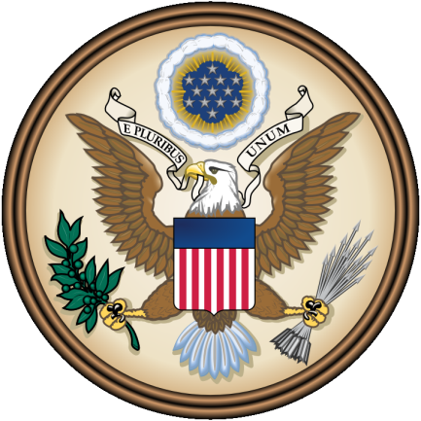
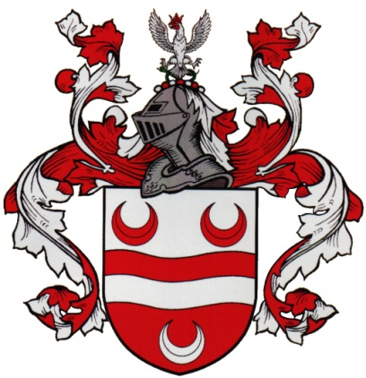
The Coat of Arms

The tradition of a Coat of Arms originally comes from the era of medieval warfare. Knights locked in combat could not tell friend from foe in the heat of battle. Among other methods, adorning armor with unique symbols was a simple way to identify who was involved in the fighting. The practice of having a coat of arms spread throughout the world, and became an important part of many different cultures. Today, a coat of arms can be used to identify certain individuals, traditional families or clans, and even countries.
Your task is to create your own Coat of Arms that represents you and the things that are important in your life. After completing your design, write a paragraph or two summarizing the things that you included in your Coat of Arms. Hopefully, between the paragraphs and the design itself, I should be able to learn a lot about what makes you who you are!

What is History to you?
Name: ______________
- What is something you like about history?

- What is something you don’t like about history?

- What is your favorite thing or time in history to learn about?

- What are two goals you have for this class?

- What can I do to help you reach these goals?

